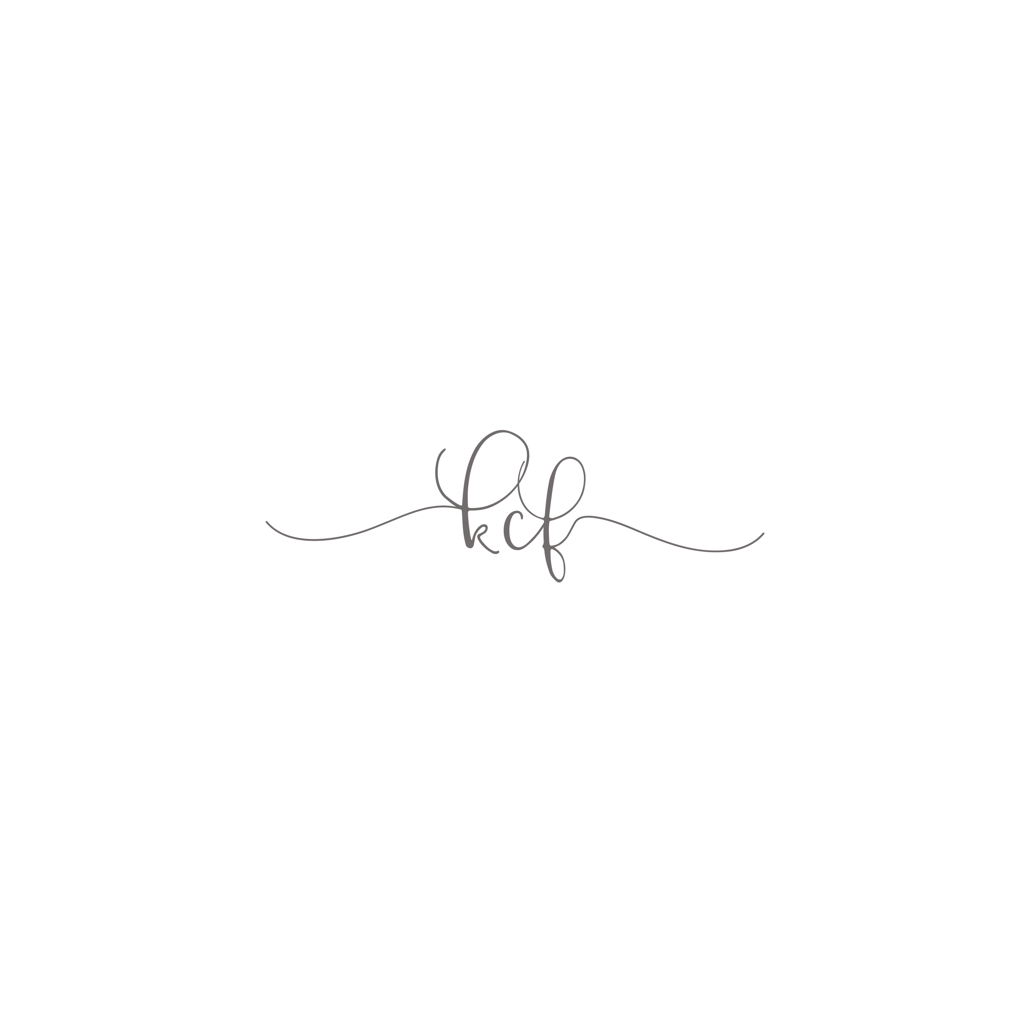

**White Rectangle Tables**

**8= 72”x 30”**

**White Round Tables**

**8= 60” round**

**Also Available:**

**Rectangle Farmhouse Table**

**2 Square Wooden Tables 60” x 60”**

**Chairs**

**250 White**

